# **CTF Challenge: - Using Ping.eu for Port Check**

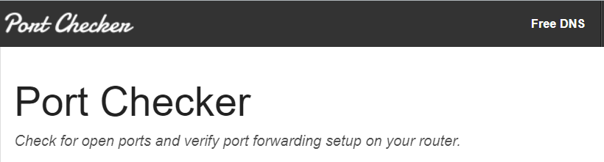

# **1. Introduction**



Ping. EU is an online tool that provides various network utilities, including port checking, to determine if a specific port on a given IP address is open or closed. This challenge will introduce you to using Ping. eu to check the availability of a port on a specific IP address.

# **2. Tools and Requirements**

* Access to the internet and GreyNoise

# **3. Scenario**



You are a network administrator responsible for ensuring that critical services are accessible. Your task is to use Ping.eu to check if a specific port on a given IP address is open and available for connections.

# **4. Process to follow while performing CTF**

1. Visit Ping.eu: <https://ping.eu/port-chk/>

2 Enter the IP address **104.21.3.150,** port number **22** and Enter the captcha code that is shown and click on the Go option.

3. Solve the CTF.

# **5. Let’s Begin the Challenge**

**Question**

**Flag 1: Is Port 22 open or closed?**

*Answer: closed*

Flag Captured

